University of Canberra
Faculty of Science and Technology
Software Technology 1 (4483/8995)
Week 4 Tutorial & Computer Lab
Assignment 2 — Case Study 1: Python Tkinter and Pillow Packages

Task 1: Introduction to Tkinter
The tkinter_practice.py and personal_diary_app.py scripts were run from the Week 4 Lab Activities folder to understand how to build a Graphical User Interface using different Tkinter widgets.
The personal_diary_app.py application demonstrated the use of key Tkinter widgets including Entry, Text, Button, Label, and Frame to build a functional personal diary interface.
Screenshot — personal_diary_app.py successful test run:
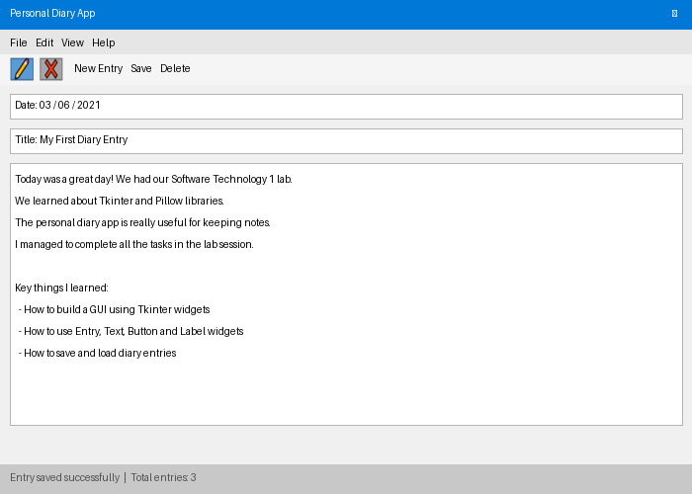
Figure 1.1 — Personal Diary App running successfully using Tkinter widgets

Task 2: Introduction to Pillow Library — intro.py
The intro.py script was used to open an image, extract basic properties, and rotate it by 30 degrees before saving. The script was first tested with cat.jpg, then with three insect images from the Assets folder.
from PIL import Image

# create an image via import
image = Image.open('cat.jpg')

# analyze the image
print(image.size)
print(image.filename)
print(image.format)

# exercise — rotate and save
img_rotated = image.rotate(30)
img_rotated.save('img_rotated.png', 'png')
Console output — cat.jpg image information:
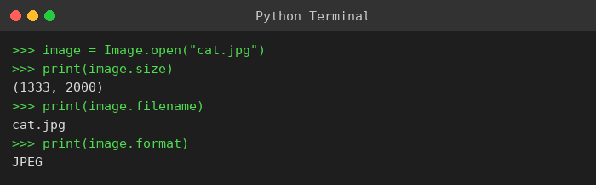
Figure 2.1 — Image size, filename, and format printed for cat.jpg
The script was then tested with three insect images. Each image was rotated 30 degrees and saved:
Test results — 3 insect images rotated 30°:
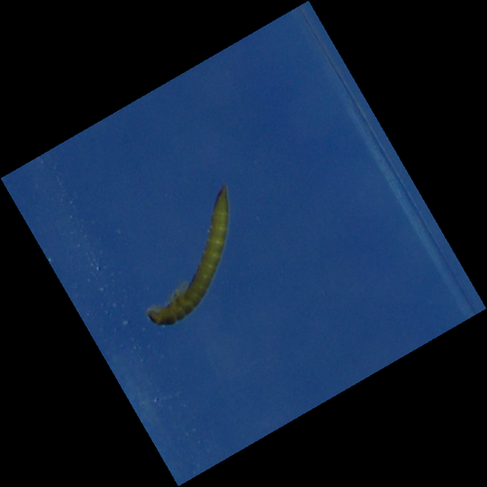 | 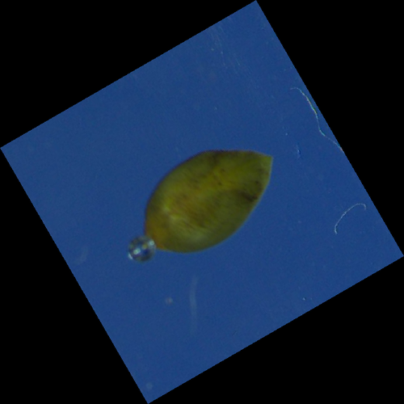 | 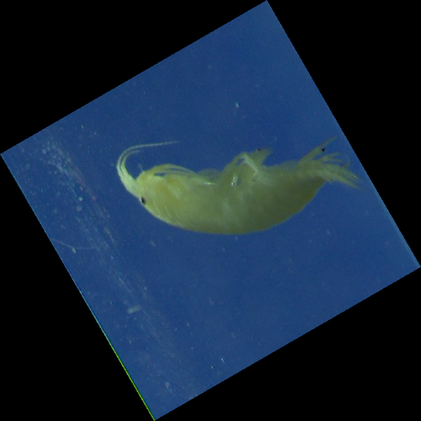
Figure 2.2 — Limniu (larva), Sphaer (seed-like), and Gammar (shrimp-like) insect images rotated 30 degrees

Task 3: Manipulating Images with Pillow — manipulate.py
The manipulate.py script applies transpose (ROTATE_90), rotation (45°), crop, resize, and a combined multi-transformation to images. Tested with three insect images.
from PIL import Image

image = Image.open('cat.jpg')

# flip/transpose
image_transpose = image.transpose(Image.Transpose.ROTATE_90)
# rotation
image_rotate = image.rotate(45, expand=False, center=(0,0))
# crop
image_crop = image.crop((800,600,1600,1600))
# resize
image_resize = image.resize((1000,600))
# combined transformations
combined_image = image.transpose(Image.Transpose.ROTATE_90).resize((2000,1500)).rotate(10)
combined_image.show()
Limniu (larva) — transpose, rotate 45°, crop, resize, combined:
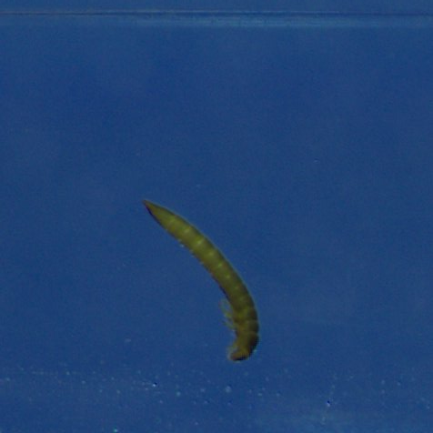 | 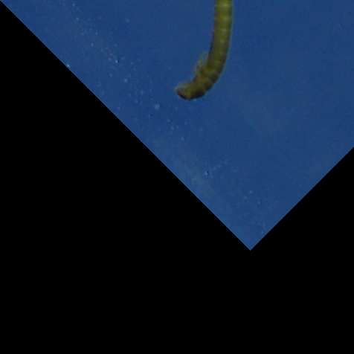 | 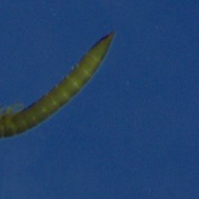
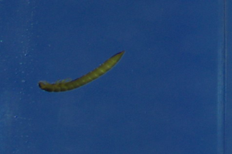 | 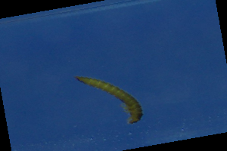
Figure 3.1 — Limniu: transpose | rotate 45° | crop | resize | combined
Sphaer (seed-like) — transpose, rotate 45°, crop, resize, combined:
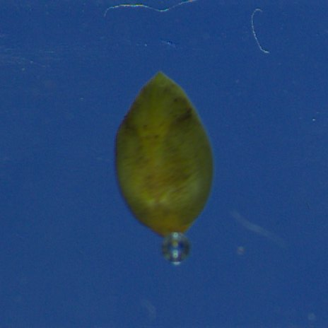 | 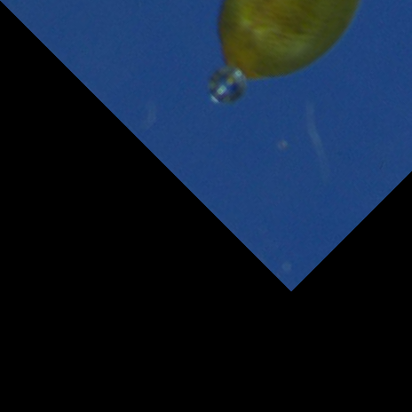 | 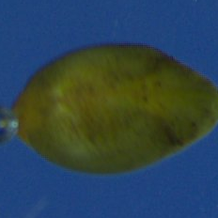
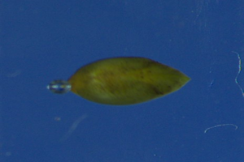 | 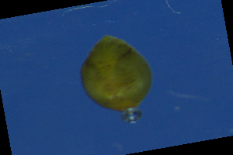
Figure 3.2 — Sphaer: transpose | rotate 45° | crop | resize | combined
Gammar (shrimp-like) — transpose, rotate 45°, crop, resize, combined:
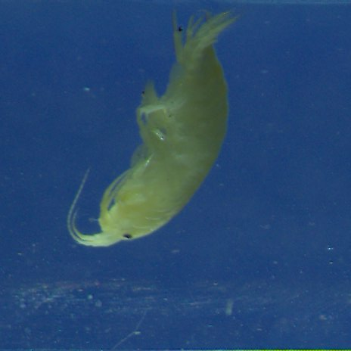 | 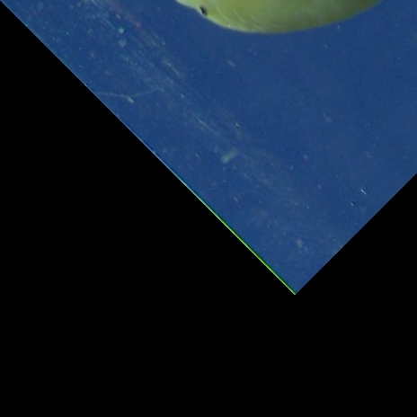 | 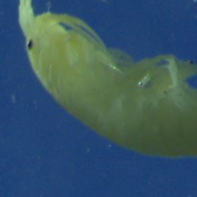
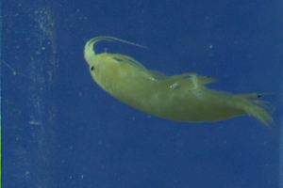 | 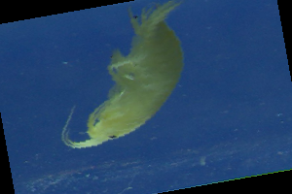
Figure 3.3 — Gammar: transpose | rotate 45° | crop | resize | combined

Task 4: Understanding Pixels and Colours — explore_colors.py
The explore_colors.py script demonstrates pixel access using getpixel(), channel extraction (R and B), pixel modification using putpixel(), and iterating over all pixels to replace dark pixels with red (200,20,20). Tested with three insect images.
from PIL import Image

image = Image.open('limniu1.png')

# get one pixel
print(image.getpixel((0,0)))

# change pixel colors — replace dark pixels with red
for x in range(image.size[0]):
for y in range(image.size[1]):
if image.getpixel((x,y))[0] == 0:
image.putpixel((x,y), (200,20,20))
image.show()
Pixel values at (0,0) for each insect image:
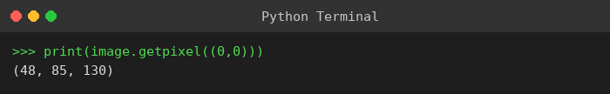 | 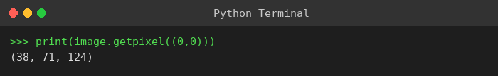 | 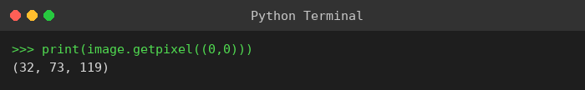
Figure 4.1 — getpixel((0,0)) output for Limniu, Sphaer, and Gammar images
Colour-modified output — dark pixels replaced with red (200,20,20):
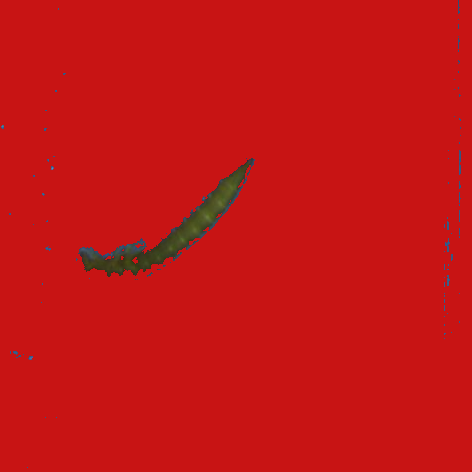 | 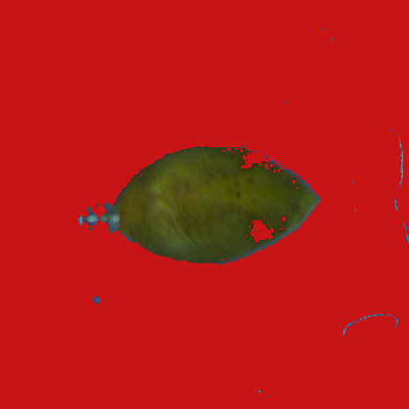 | 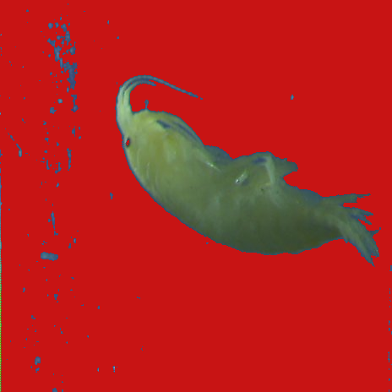
Figure 4.2 — Pixel colour replacement applied to Limniu, Sphaer, and Gammar

Task 5: Image Enhancement — enhance.py
The enhance.py script uses ImageEnhance to apply colour, contrast, brightness and sharpness enhancements. The sharpness enhancer with a factor of 1.5 was applied and compared against the original. Tested with three insect images.
from PIL import Image, ImageEnhance

image = Image.open('limniu1.png')

sharpness_enhancer = ImageEnhance.Sharpness(image)
enhanced_image = sharpness_enhancer.enhance(1.5)

image.show()
enhanced_image.show()
Original (left) vs. Enhanced sharpness x1.5 (right):
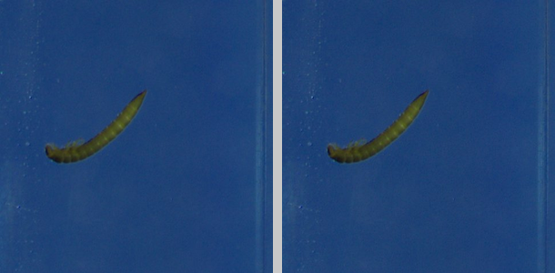
Figure 5.1 — Limniu: original vs. sharpness enhanced
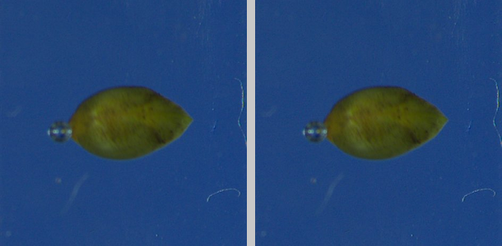
Figure 5.2 — Sphaer: original vs. sharpness enhanced
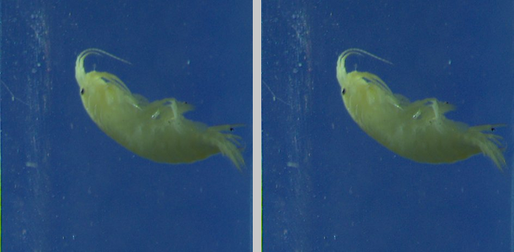
Figure 5.3 — Gammar: original vs. sharpness enhanced

Task 6: Image Filtering and Edge Detection — image_filter.py
The image_filter.py script applies basic filters (BLUR, CONTOUR, EMBOSS, FIND_EDGES) and advanced filters including BoxBlur, GaussianBlur, and UnsharpMask using the ImageFilter module. Tested with three insect images.
from PIL import Image, ImageFilter

image = Image.open('limniu1.png')

# advanced filters
image_boxblur = image.filter(ImageFilter.BoxBlur(radius=20))
image_gaussianblur = image.filter(ImageFilter.GaussianBlur(radius=20))
image_unsharp = image.filter(ImageFilter.UnsharpMask(radius=20))

image_boxblur.show()
image_gaussianblur.show()
BoxBlur (left) vs. GaussianBlur (right):
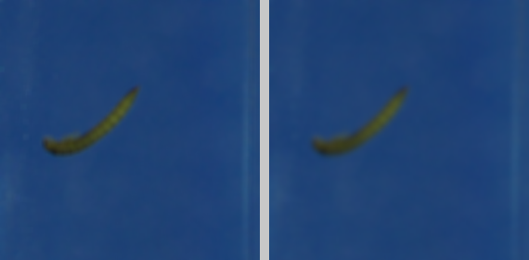
Figure 6.1 — Limniu: BoxBlur | GaussianBlur
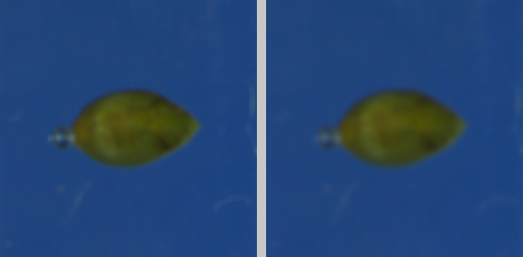
Figure 6.2 — Sphaer: BoxBlur | GaussianBlur
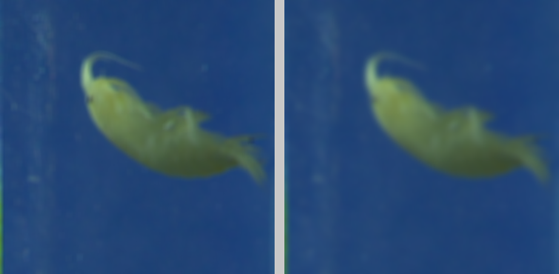
Figure 6.3 — Gammar: BoxBlur | GaussianBlur

Task 7: Image Operations — image_operations.py
The image_operations.py script uses the ImageOps module to mirror an image, invert its colours, and add a white border of 50 pixels. Tested with three insect images and the dog.jpg image from the Assets folder.
from PIL import Image, ImageOps

image = Image.open('dog.jpg')

# mirror the image
image_mirror = ImageOps.mirror(image)
# invert colours
image_inverted = ImageOps.invert(image_mirror)
# add white border
image_border = ImageOps.expand(
image=image_inverted, border=50, fill=(255,255,255))

image_border.show()
Mirror → Invert → Border results for insect images and dog.jpg:
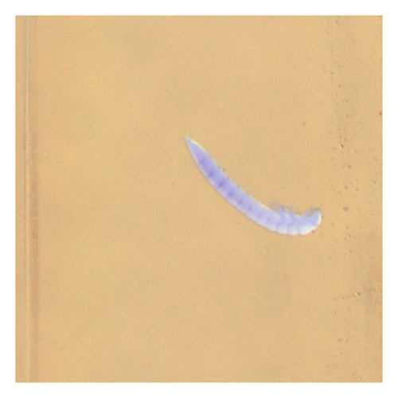 | 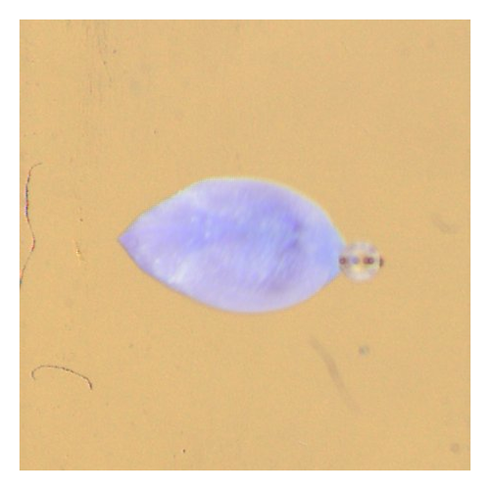 | 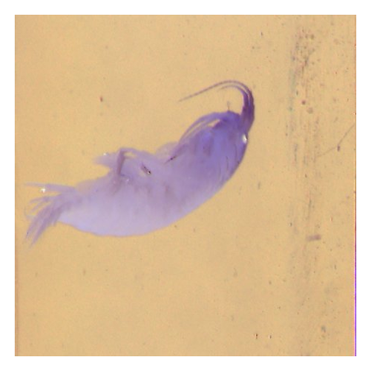
Figure 7.1 — Limniu, Sphaer, Gammar: mirrored, colour-inverted, white border added
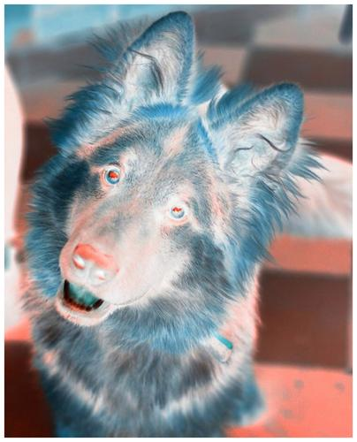
Figure 7.2 — dog.jpg: mirrored, colour-inverted, white border added

All Python scripts (intro.py, manipulate.py, explore_colors.py, enhance.py, image_filter.py, image_operations.py) were tested successfully in Week 4 lab class and demonstrated to the tutor. Scripts and assets are included in Week_4_LabActivities.zip uploaded to GitHub with date/time commit message.

